**Phase 2 - Course-end Project 1**

**Developing a Backend Admin for Learner’s Academy.**

**Developed by:** Narendra Kumar .V

(Emp-ID_10847)

**Project objective:**

As a Full Stack Developer, design and develop a backend administrative portal for the Learner’s Academy. Use the GitHub repository to manage the project artifacts.

**Background of the problem statement:**

Learner’s Academy is a school that has an online management system. The system keeps track of its classes, subjects, students, and teachers. It has a back-office application with a single administrator login.

**Project Overview:**

This is a Backend Administrator Web app Which is a internal Software used to Perform day to day operations in the organization

This software is used for maintaining and managing Schools details like list of subjects list of Students ,list of classes , list of teachers

This is also used to assign Subjects to classes and also assign teachers to classes of a particular subject

Here in the Master list of classes You can see all the details of a Class like teacher , subjects and teachers and Subjects timing

There is link at the end of classes table if you click that you will see list of all Students in that class only

**Sprint Planning:**

I have Dividing the project into 4 sprints

--Before the first sprint I have listed out the features and operations to be performed in the project and noted down

**First Sprint :-**

--In the first Sprint I have coded a basic template for front end part pages like login page sidebar and tables for displaying the data from data base, for assigning the data I have prepared some forms

**Second Sprint :-**

--After the ­First Sprint Create a database Struture like what will the different table I have to create and values in that tables like

--I have to create 4 tables for this project Students,Subjects,Teachers,Classes classes table will have Foreign key of Teacher’s id, Subject’s ID, Student’s ID , Which will point to the different tables

**Third Sprint :-**

--Here I wrote the backend part like servlets and mysql connection and retrieving of data for each table

--I have taken a Main servlet which will have a switch method for redirecting all the different servlets and sending the retrieving data to jsp pages for displaying

**Fourth Sprint :-**

--In the fourth Sprint I have verified the whole Project for exceptions and errors and resolved them so that user can have a smooth Experience Like Invalid data in table will throw an Exception and Invalid Credentials

**Flow Chart of the Project**

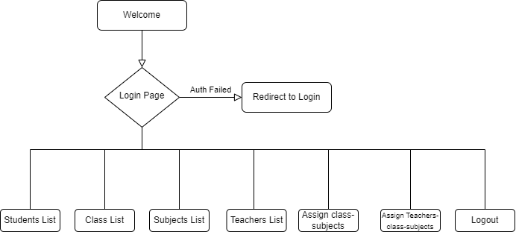

**Java Concepts Used:**

Servlets

JSP Include

Datasource for connecting to the database

Connection

Statements

**Project Github link:** [**Github Learner’s Academy Project**](https://github.com/Naren-18/Teksystems_Phase_2_Projects/tree/main/Learners%20Academy)

**Conclusion and Unique Selling Points:**

This is a Prototype Project for School administration Software

This Project can be enhanced by student and teacher login so that they can update student attendance and marks in the portel and Student can view that data when ever they want